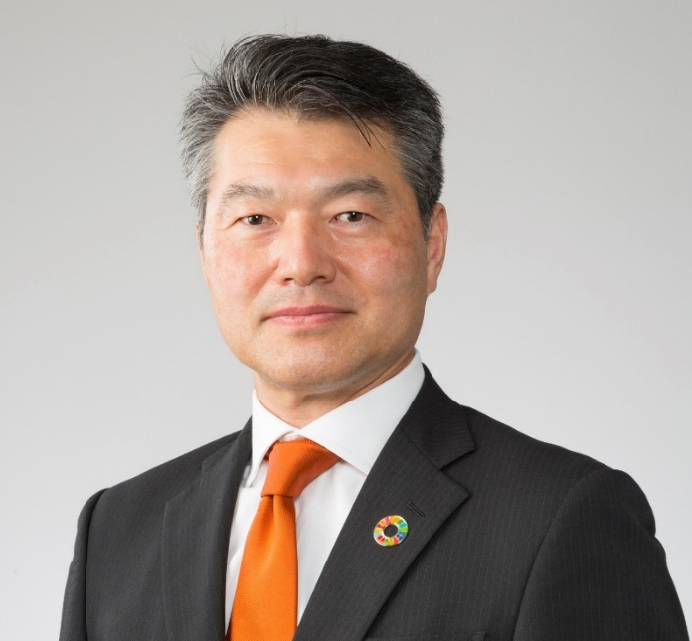

Mr. Masafumi Senzaki
Representative Executive Officer, President and Executive Officer, COO
Hitachi Construction Machinery, Japan

Profile

Originally from Chiba Prefecture, Mr. Masafumi Senzaki graduated as a Mechanical Engineer from Graduated School of Tokyo Institute of Technology in 1991.
Mr. Masafumi Senzaki has held various senior roles at Hitachi Construction Machinery (HCM) starting by working as a senior engineer for the production department, managing the assembly section, GM for the production engineering centre, GM at LLC HCM Eurasia, senior officer president at LLC HCM Eurasia, executive office and president for marketing group, vice president and executive officer for the corporate strategy group.
Since April 2023, Mr. Masafumi Senzaki has been enjoying his new challenging position as a representative executive officer, president and executive officer, COO for HCM.

