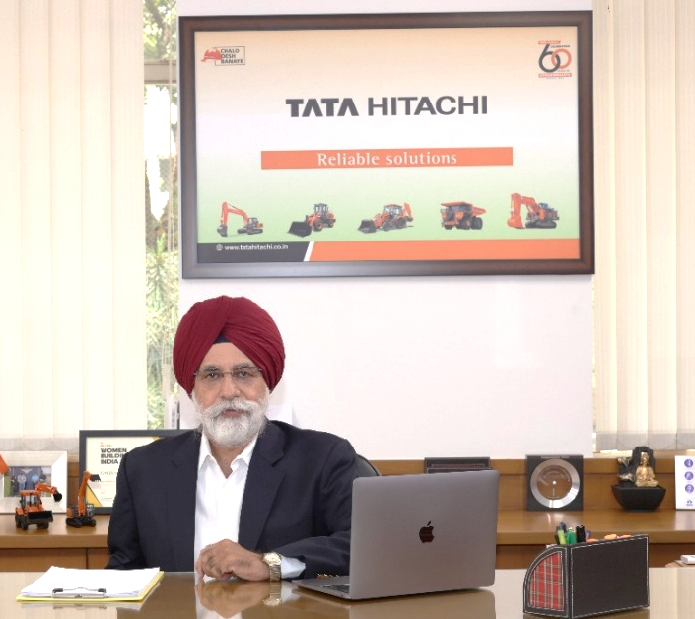

Mr. Sandeep Singh
Managing Director
Tata Hitachi Construction Machinery Company Pvt. Ltd.

Profile

Mr. Sandeep Singh is a professional with a vision. A vision complemented by profound leadership and executive presence that empowers him to lead multinational organizations with aplomb.
With an excellent knowledge of crafting marketing strategies and focusing on successful execution, Sandeep Singh has hands-on experience in spearheading organizations.
An engineering graduate from National Institute of Technology, Surat, he has a rich experience of over three decades in Sales, Marketing, Customer Support, and General Management.
He has spent a large part of his career with a reputed Automobile MNC at a leadership post.
Mr. Sandeep Singh joined as Managing Director of Tata Hitachi Construction Machinery Company Private Limited in August 2015, where he is guiding the company through its next phase of growth. He is also the Executive Officer- Hitachi Construction Machinery, Japan.
The top leadership positions held by him earlier:
- Executive Managing Coordinator, Strategic Planning -Toyota Motor Asia Pacific Engineering & Manufacturing Co. Ltd, Thailand
- Dy. Managing Director & Chief Operating Officer - Toyota Kirloskar Motor P. Ltd.
- Ex-Chairman - Confederation of Indian Industries – Karnataka
- Ex-President - Indian Construction Equipment Manufacturers Association
- Ex-Chairman - Infrastructure Equipment Skill Council

